**Lexar® Professional CFexpress™ Type B Card DIAMOND Series**

512GB

256GB

128GB

[Where to buy](https://americas.lexar.com/product/lexar-professional-cfexpress-type-b-card-diamond-series/)

**Key Features:**

**Up to 1900MB/s read,  1700MB/s write speeds**

**Sustained write speed of 1600 MB/s**

* Superior performance
* Smooth 8k Video
* Backwards Compatibility
* VPG 400 video class

**Key Features:**

**Up to 1900MB/s read,  1700MB/s write speeds**

**Sustained write speed of 1600 MB/s**

* Superior performance
* Smooth 8k Video
* Backwards Compatibility
* VPG 400 video class

**Key Features:**

**Up to 1900MB/s read,  1700MB/s write speeds**

**Sustained write speed of 1600 MB/s**

* Superior performance
* Smooth 8k Video
* Backwards Compatibility
* VPG 400 video class

[Features](https://americas.lexar.com/product/lexar-professional-cfexpress-type-b-card-diamond-series/#feature-section)[Specifications](https://americas.lexar.com/product/lexar-professional-cfexpress-type-b-card-diamond-series/#specifications)[Part Numbers](https://americas.lexar.com/product/lexar-professional-cfexpress-type-b-card-diamond-series/#product-numbers)[Related products](https://americas.lexar.com/product/lexar-professional-cfexpress-type-b-card-diamond-series/#related-products)

**Features**

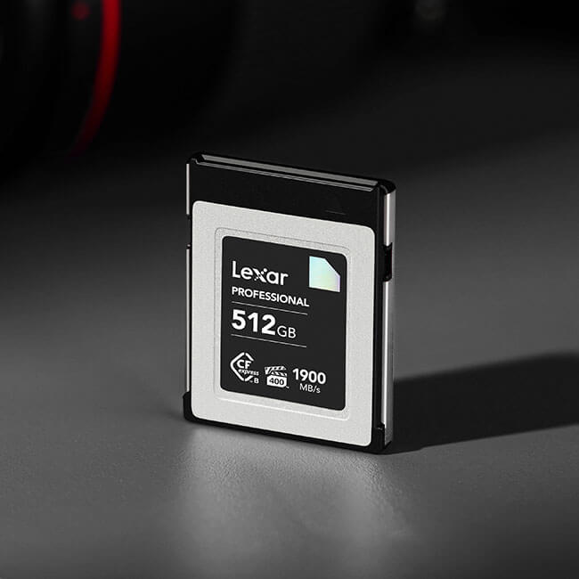

**Unmatched performance to capture smooth 8K RAW video**

From field to post-production, experience the unmatched performance of the Lexar® Professional CFexpress™ Type B Card DIAMOND Series. Designed to meet the demands of professional filmmakers and content creators, this card unleashes blazing-fast speeds of up to 1900MB/s read and 1700MB/s write, and minimum sustained write speed of 1600MB/s1 to capture smooth RAW 4K, 6K, 8K and beyond video with sustained performance.

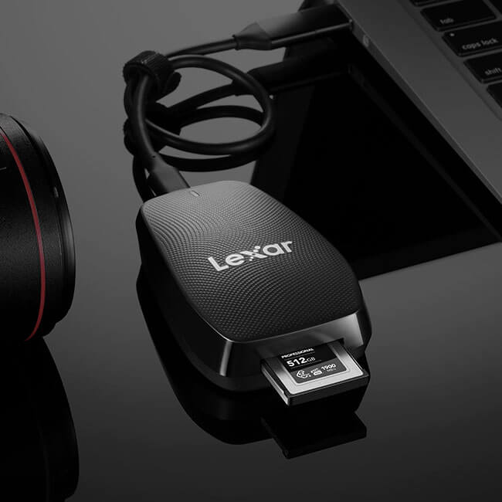

**Dramatically accelerate your workflow**

The blazing-fast performance of the Lexar®Professional CFexpress™ Type B Card DIAMOND Series allows you to capture and transfer content quickly and efficiently. And with an industry-leading read transfer speed up to 1900MB/s,1 you’ll quickly power through post-production and dramatically accelerate your workflow from start to finish.

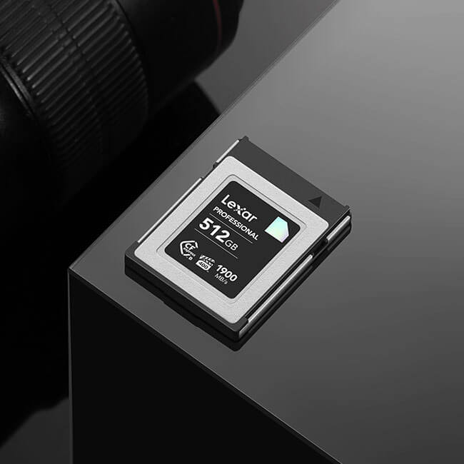

**Supports smooth 8K video performance**

Featuring PCIe Gen 3×2, NVMe high-speed protocols, and a write speed of up to 1700MB/s,1 this card captures the highest quality RAW, ProRes, and 8K video with ease. It also meets the VPG400 specification for professional-quality video, meaning it’s guaranteed to capture video streams at a minimum guaranteed write speed of 400MB/s1 when used with compatible host devices and recording media.

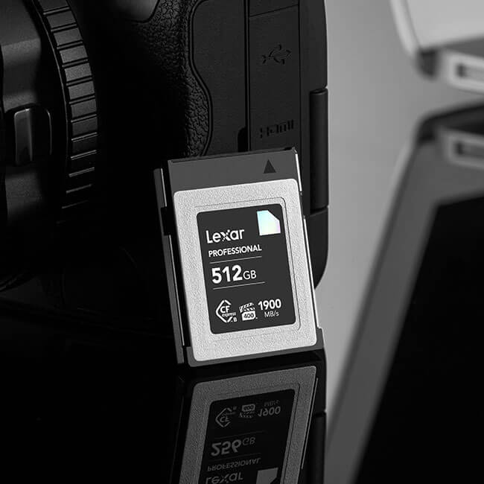

**Backwards-compatible with XQD® cameras**

For added versatility, Lexar® Professional CFexpress™ Type B DIAMOND Series is backwards-compatible with select XQD® cameras,2 enabling existing devices with next-generation performance.



**Capture adventure with ultimate durability**

The Lexar® Professional CFexpress™ Type B Card DIAMOND Series is built with the rugged durability you need to capture even in the harshest of conditions. The cards are designed to be shock and vibration-proof, and resistant to extreme temperatures.* And, for added peace of mind, the card is backed by a Limited Lifetime Warranty.3

**Rigorously Tested**

All Lexar products undergo extensive testing in the Lexar Quality Labs, facilities with thousands of different cameras and digital devices to ensure performance, quality, compatibility, and reliability.

**Specifications**

* Capacity

128GB / 256GB / 512GB

* Form Factor

CFexpress Type B

* Interface

PCIe Gen3x2

* Performance

Up to 1900MB/s read, 1700MB/s write speeds1

* Sustained Write Speed

1600 MB/s

* Operating Temperature

-10°C~70°C (14°F~158°F)

* Storage Temperature

-25°C~85°C (-13°F~185°F)

* Dimension (LxWxH)

29.60 mm x 38.50 mm x 3.80 mm / 1.16” x 1.51” x 0.14”

* Weight

7.65g / 0.016lbs

* Warranty

Lifetime limited warranty